|  |  |  |  |  |  |  |  |
| --- | --- | --- | --- | --- | --- | --- | --- |
| **Date:** | **26-05-20** | | | | **Name:** | **TANOJ M** | |
| **Sem & Sec** | **VI A** | | | | **USN:** | **4AL16CS113** | |
| **Online Test Summary** | | | | | | | |
| **Subject** | | **CGV 2 IA Test** | | | | | |
| **Max. Marks** | | **30** | | **Score** | | **20** | |
| **Certification Course Summary** | | | | | | | |
| **Course** | **Front end development in HTML** | | | | | | |
| **Coding Challenges**  **C program to print all permutations of given string using pointers** | | | | | | | |
| **Certificate Provider** | | | **Great learning** | **Duration** | | | **6DAYS** |
| **Status:Completed** | | | | | | | |
| **Uploaded the report in Github** | | | | **Yes** | | | |
| **If yes Repository name** | | | | https://github.com/Tanoj8296/DAILY-STATUS | | | | |
|  | | | | |
| **Uploaded the report in slack** | | | | **Yes** | | | |

**DAILY ONLINE ACTIVITIES SUMMARY**

**Ce Certification Details**

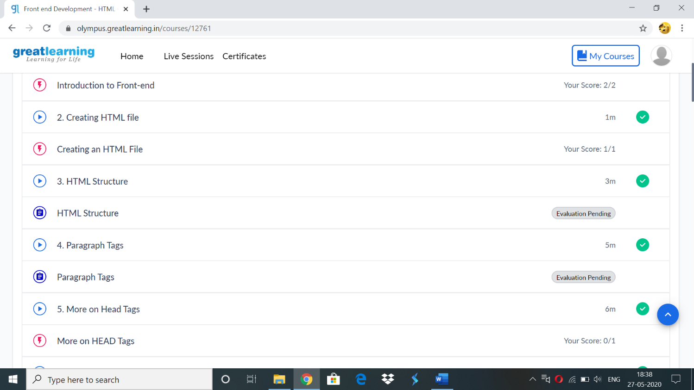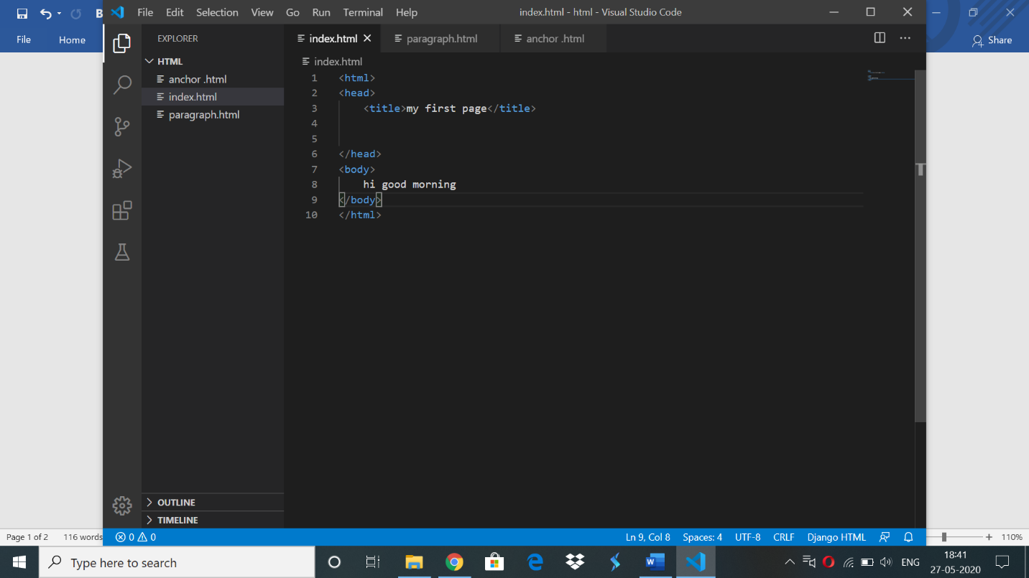

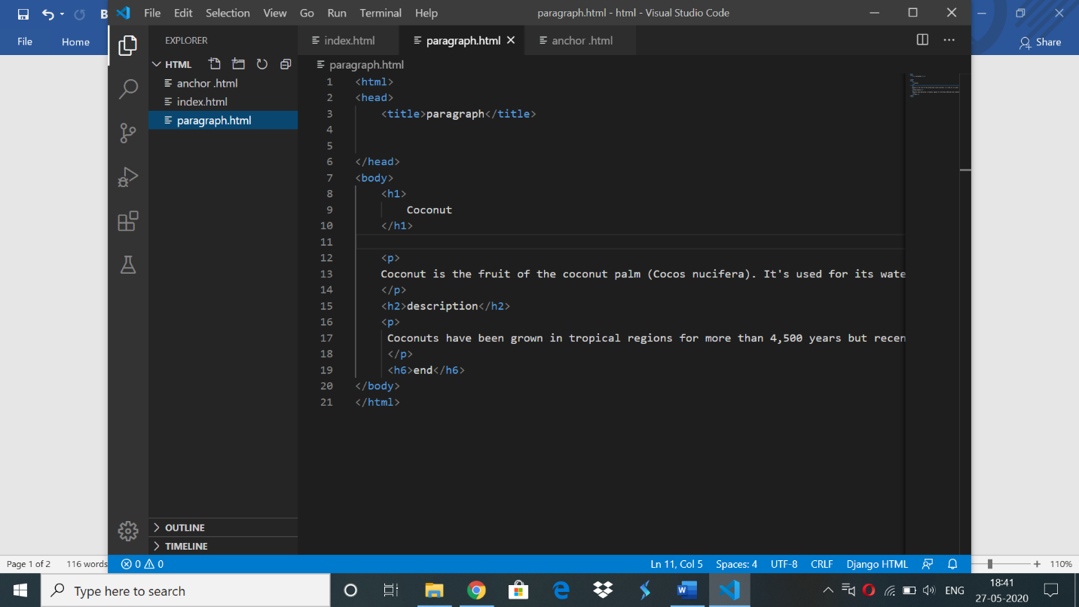

Online codding challenge:

#include <stdio.h>

#include <string.h>

/* Function to swap values at two pointers */

void swap (char *x, char *y)

{

char temp;

temp = *x;

*x = *y;

*y = temp;

}

/* End of swap() */

/* Function to print permutations of string */

void permute(char *a, int i, int n)

{

int j;

if (i == n)

printf("%s\n", a);

else {

for (j = i; j <= n; j++)

{

swap((a + i), (a + j));

permute(a, i + 1, n);

swap((a + i), (a + j)); //backtrack

}

}

}

/* The main() begins */

int main()

{

char a[20];

int n;

printf("Enter a string: ");

scanf("%s", a);

n = strlen(a);

printf("The permutations of the string are :");

permute(a, 0, n - 1);

getchar();

return 0;

}

**OUTPUT:**

